

Mathematics Specialist Unit 1

Test 4

Trigonometry

Name: ______________________ Total Marks:__________

Task type: Response

Time allowed for this task: 60 minutes, in-class, under test conditions
Section One: Calculator-free 25 minutes ( 25marks)
Section Two: Calculator-assumed 35minutes ( 35marks)

Materials required: Calculator with CAS capability (to be provided by the student)

Standard items: Pens (blue/black preferred), pencils (including coloured), sharpener, correction fluid/tape, eraser, ruler, highlighters

Special items: Drawing instruments, templates, notes on one unfolded sheet of
A4 paper, and up to three calculators approved for use in the WACE examinations
Formula sheet

Marks available: 60 marks

Task weighting: 7%

Section One : Calculator Free Marks
Time Allowed minutes

Question 1
[3 marks]
Solve the equation $2\sin\left(x-\frac{π}{2}\right)=-1$

Question 2
[5 marks]
Find all the solutions (in radians) for $θ$ in $2\sin^{2}{θ+\cos{θ=2}}$

Question 3
[3 marks]
On the grid below draw the graph of $y=sec({x)-1}$

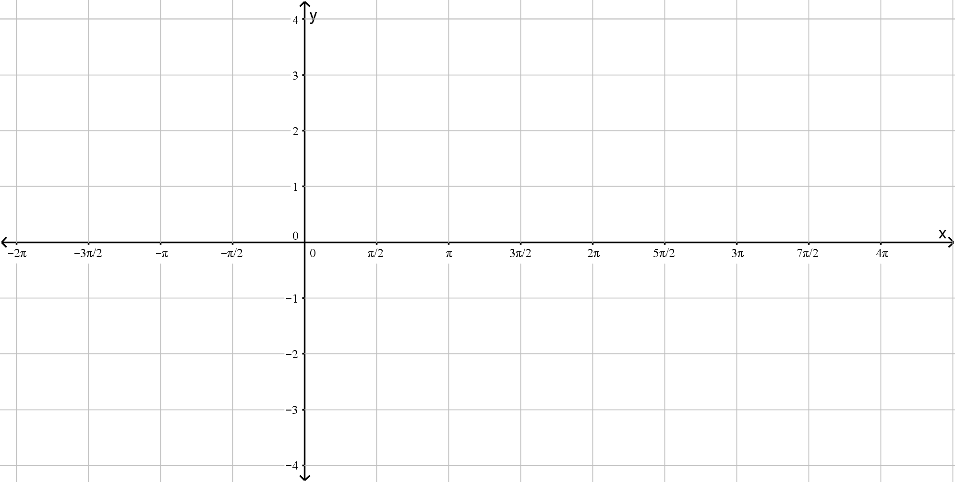

Question 4
[4 marks]
Evaluate:

- $cos75°cos15°.$

- $\sin{\frac{11π}{12}}\sin{\frac{π}{12}}$

Question 5
[9 marks]
Prove that, for $\cos{x≠0}$,
$\sin{2x}-\tan{x}≡\tan{x\cos{2x}}$

Hence, or otherwise, solve the equation

$$\sin{2x}-\tan{x}≡\sqrt{3}\cos{2x}$$

For $0≤x≤180°$

Question 6
[2 marks]

Question 7
[2 marks]

Section Two : Calculator Assumed Mark
Time Allowed 35 minutes Name:_______________________

Question 8
[9 marks]

- Express $2\sin{x}-3\cos{x}$ in the form $R\sin\left(x-α\right)$ where $R>0$and $0<α<90°$. Hence find the exact value or $R$ and $α$ to two decimal places.

- Show that the equation $\operatorname{cosec}{x}+3\cot{x}=2$ can be written in the form $2\sin{x}-3\cos{x=1}$

- Solve the equation $\operatorname{cosec}{x}+3\cot{x}=2$ for $0<x<360°$ giving your answers to one decimal place.

Question 9
[13 marks]
Prove the following identities

- $\sin\left(3θ\right)=3\sin{θ-4\sin^{3}{θ}}$

- $2\cot\left(2θ\right)+\tan{θ}≡\cot{θ}$

- $\sec^{2}{θ}=\sec{θ}\operatorname{cosec}{θ}\tan{θ}$

Question 10
[6 marks]

Question 11
[8 marks]

Question 12
[8 marks]

